Our suggestions for things to see and do in the local area

The coast…
Pineto, Silvi, Roseto degli Abruzzi.
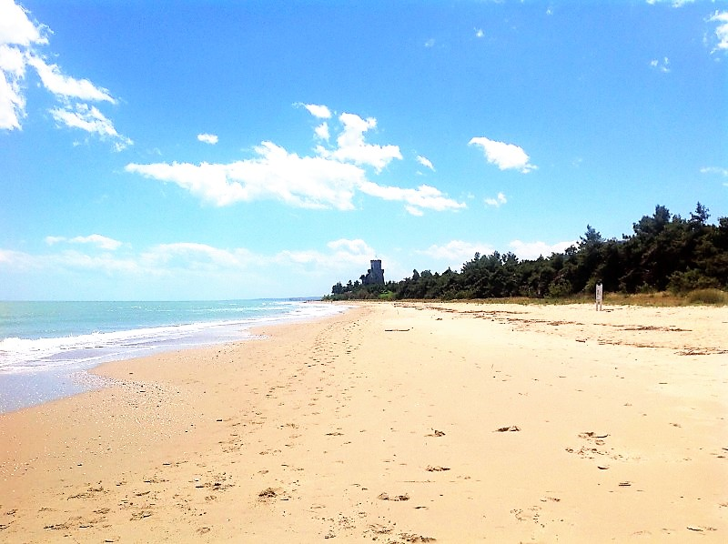
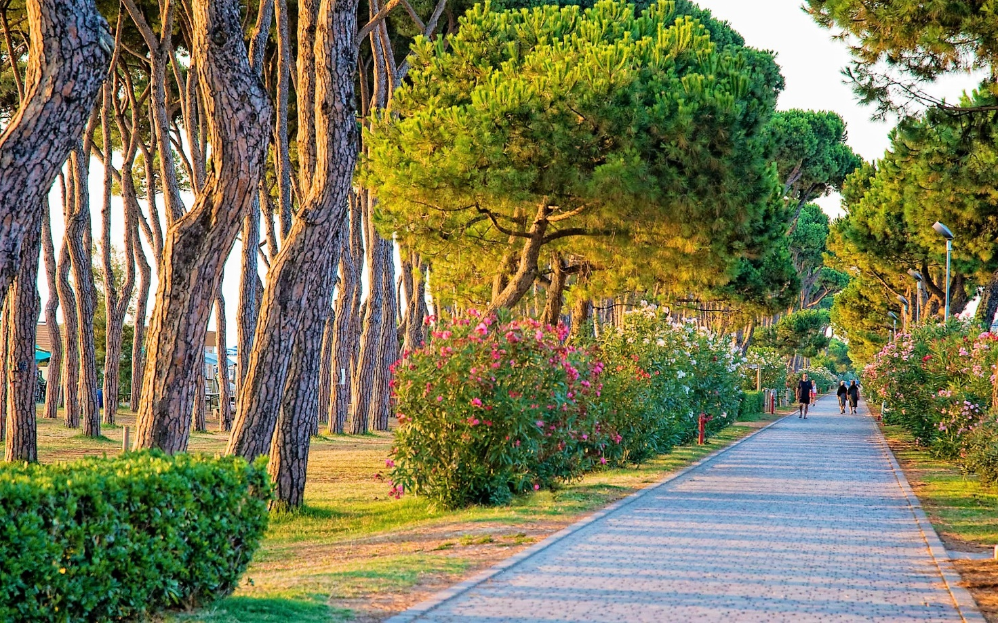
Pineto, a quiet city famous for its green and refreshing pine forest along the coast, for years "Blue Flag" for the clarity of its waters, elected by a special classification as one of the most beautiful beaches in Italy.
https://maps.app.goo.gl/jHwNQP3s76mTLD1R7
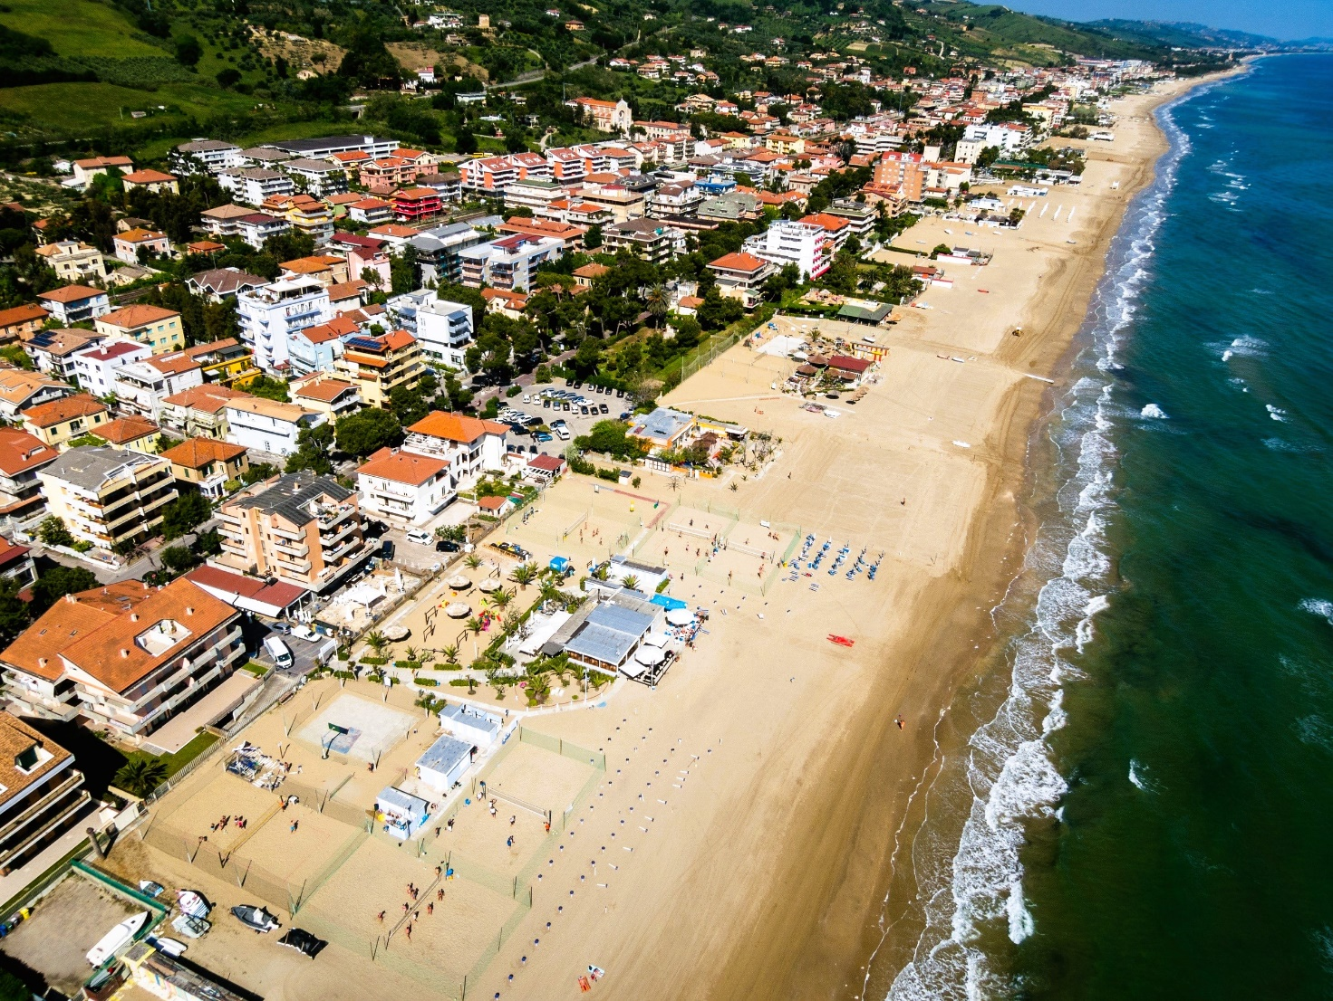
Silvi, known as the "Pearl of the Adriatic", is a splendid seaside resort, an enchanting town that can boast among its particularities, the beauty of the beaches and the emerald colour of the sea waters.
https://maps.app.goo.gl/z72no385nC19nBJdA
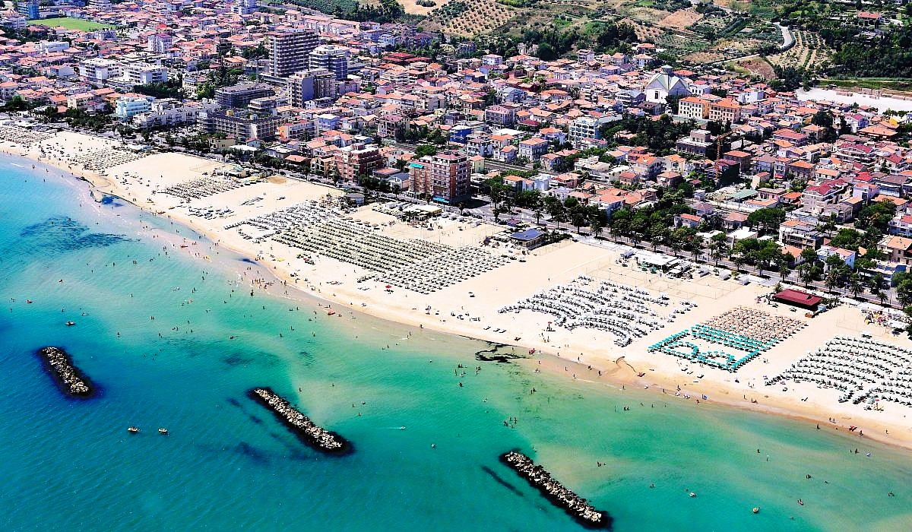
In Roseto degli Abruzzi there are several beaches, both equipped and free to use, characterized by a wide, sandy shore and a crystal clear sea with shallow waters. The seaside resort of Roseto holds both the Blue Flag title, for the quality and cleanliness of the water, and the Green Flag title, awarded to the city for the best beaches equipped for children. https://maps.app.goo.gl/QeSwF5sYNo8NFjV77

At approximately 70 minutes
La Costa dei Trabocchi
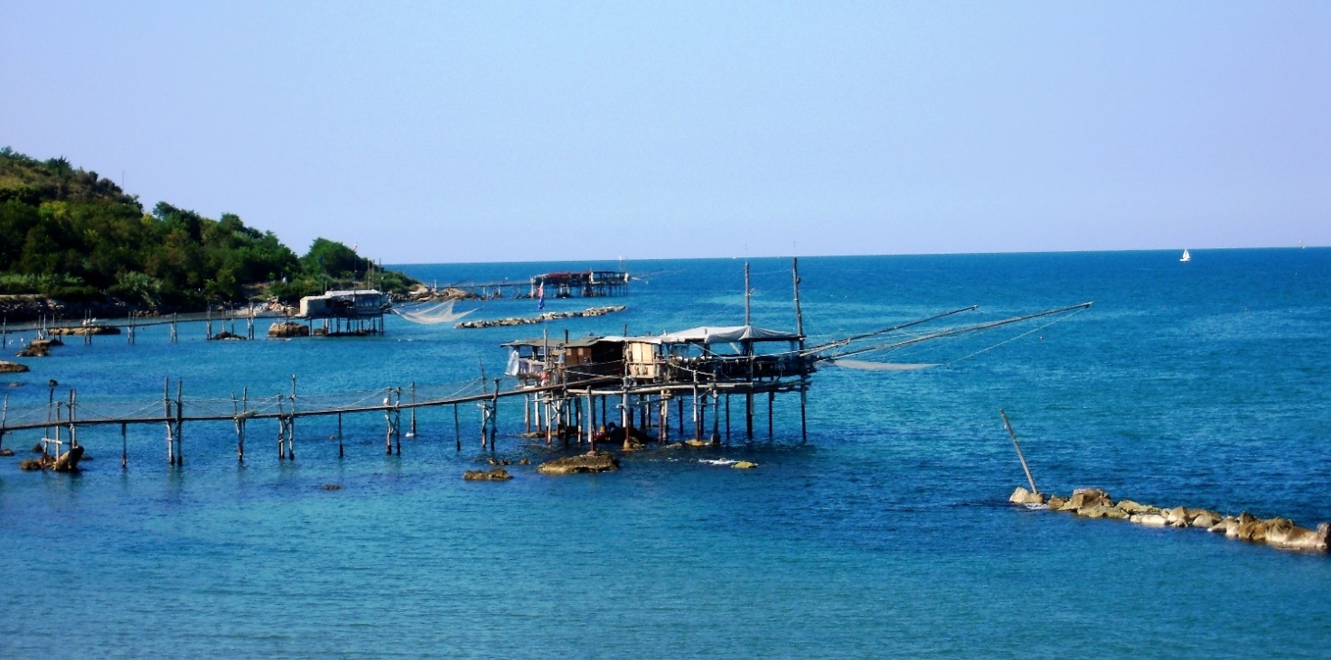
Ancient fishing huts that tell the story of a people, trabocchi characterize the Chieti coast, the southernmost area of Abruzzo, and are part of the traditional heritage of the region. Built along the beaches and anchored to rocks or reefs, trabocchi are ingenious wooden constructions that were used for fishing.
The coast that goes from Ortona to Vasto, which is known as the "Costa dei Trabocchi", extends for about 40 km and sees the presence of numerous trabocchi. Some of these, respecting their original layout, have been renovated and converted into restaurants while others are open to be visited.
https://maps.app.goo.gl/B4mzzoNDQaGfUTWy7
Don't miss the unique emotion of enjoying excellent fish dishes on a trabocco, reservations are naturally recommended:
Trabocco San Giacomo
Via lungomare di Gualdo (punta molo), San Vito Chietino (Ch)
Tel. 3277791741
Trabocco Punta Fornace
Via Cristoforo Colombo, San Vito Chietino (Ch)
Tel. 3453064920
Trabocco Valle Grotte
S.S. 16 Adriatica Km 482.5, Località Fosso Canale, San Vito Chietino (Ch)
Tel. 3485479587 – 3381866074
Trabocco Pesce Palombo
S.S. 16 Adriatica, Fossacesia (Ch)
Tel. 3333055300
Trabocco Punta Rocciosa
S.S. 16 Adriatica, Fossacesia (Ch)
Tel. 3392174435

The mountains…
At approximately 90 minutes
Campo Imperatore, Santo Stefano di Sessanio, Rocca Calascio.
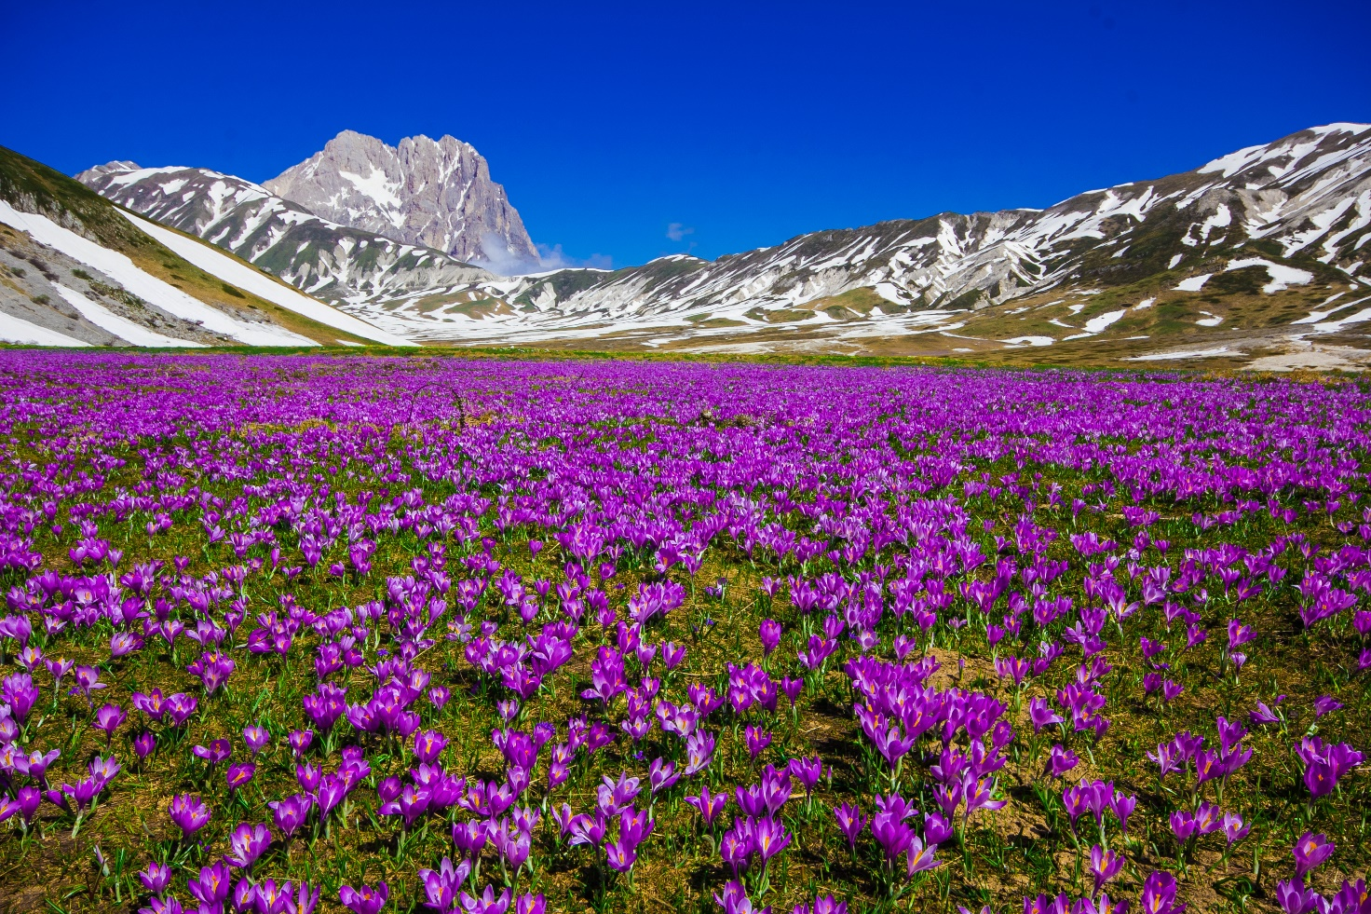
Campo Imperatore, often called the "Little Tibet" of Italy, is a vast plateau located in the heart of the Gran Sasso and Monti della Laga National Park. This magical place offers a spectacular landscape, characterized by rolling prairies and majestic mountains rising to the horizon.
https://maps.app.goo.gl/KPtPhzzxFCQi2Vx26
Campo Imperatore can be easily reached by car, but for a different and fascinating experience you can use the Gran Sasso cable car.
The Gran Sasso d'Italia cable car connects the tourist resort of Fonte Cerreto, Assergi (1,115 m asl), to the western side of Campo Imperatore (2,130 m asl), in the heart of the Gran Sasso d'Italia massif.
https://maps.app.goo.gl/fnrQVTEjfhiSJLvn9
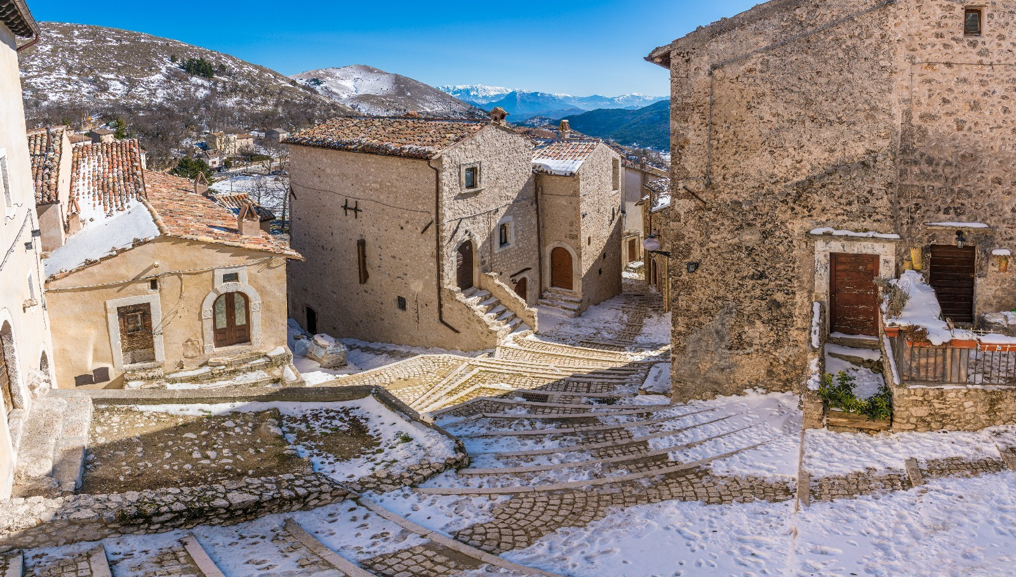

Santo Stefano di Sessanio is a medieval village of rare beauty, located within the Gran Sasso and Monti della Laga National Park. Its narrow cobbled streets, stone houses and medieval towers evoke a distant past, making Santo Stefano a magical place.
In Santo Stefano di Sessanio you can admire the art of local craftsmanship, taste the typical Abruzzo cuisine and discover the rich history of the village, visiting places such as the Medici Tower or taking part in one of the numerous cultural events that take place there during the year.

https://maps.app.goo.gl/k4V7PdaC3F5V44AQA
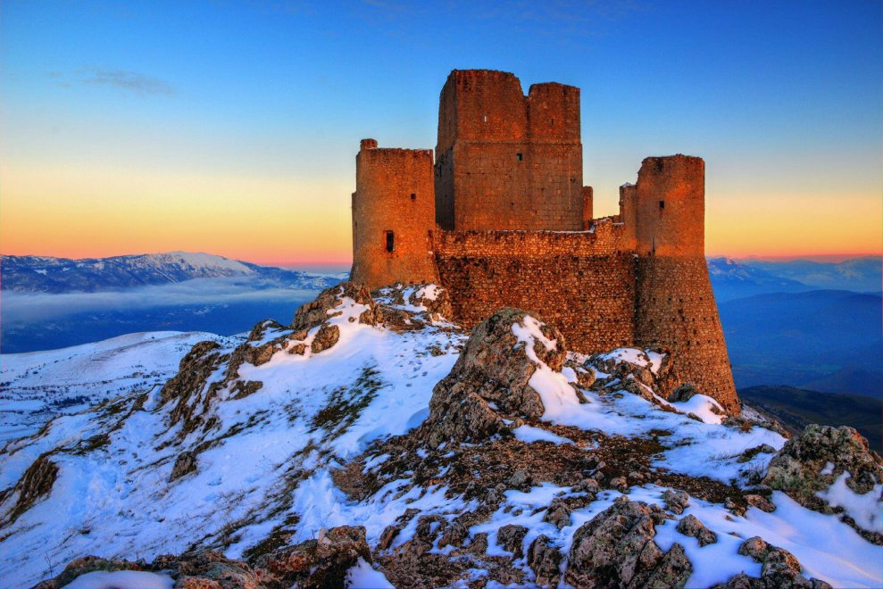

Located within the Gran Sasso and Monti della Laga National Park, Calascio is an internationally known location, for its suggestive fortress which is also considered one of the highest in Abruzzo. Around the 11th century, a watchtower was built on the mountain overlooking the territory of Calascio, about four kilometres from the village, to anticipate possible enemy assaults. This place took the name of Rocca Calascio.

https://maps.app.goo.gl/6FzoD62QN2QFVguU9
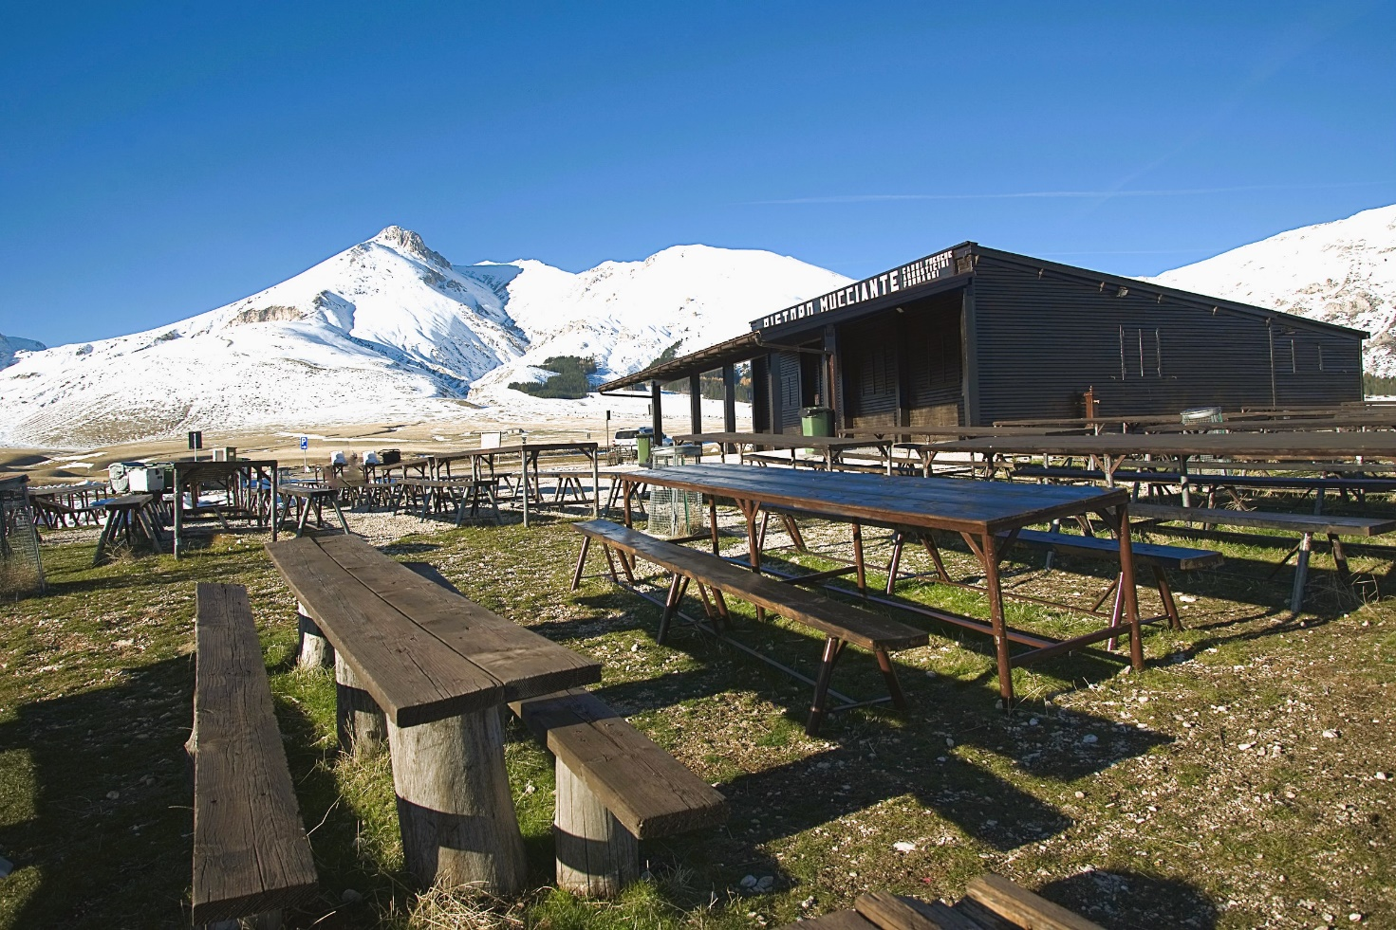

Don't miss the unique experience of a barbecue at the "Ristoro Mucciante":

The Ristoro Mucciante is located in the Piana di Campo Imperatore, in the area of Madonnina at the Bivio di Fonte Vetica. Destination for fans of arrosticini (local specialty) and grilled meats (you will find lamb, pork and veal). The barbecues are in full operation during the summer months, to cook the meats that you can purchase on site.

Ristoro Mucciante specializes in barbecues but in the shop you will also find excellent cured meats and cheeses, wines, beers and desserts. You will be provided with plates, napkins and everything you need to independently prepare an excellent meal in the open air!

How the restaurant works: once you have purchased the meat, you will be the one to cook it. You will have access to the barbecues (already ready to use) to cook it and you can freely use the tables and benches. In summer the shop remains open until around 7pm but don't worry, customers are never kicked out and the barbecues are always in operation!

www.ristoromucciante.com
https://maps.app.goo.gl/6GH7sSQMZYe6YfN96

At approximately 120 minutes

Scanno, Villalago, Villetta Barrea

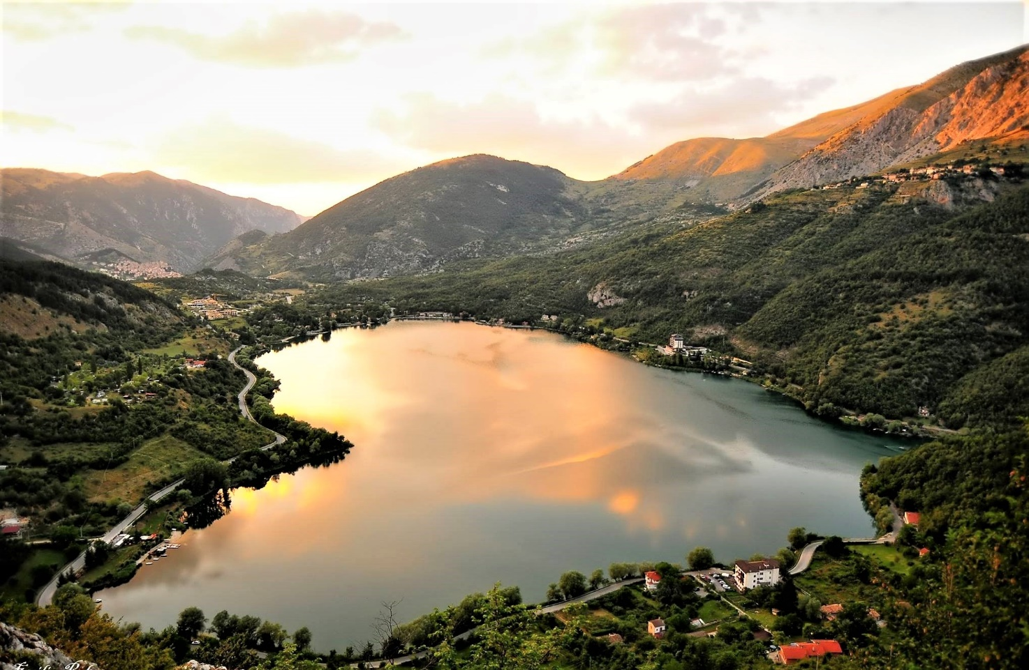

Scanno is another enchanted village in Abruzzo, known for its splendid lake and artisan tradition. The winding streets of the historic centre lead to picturesque squares and historic buildings, while Lake Scanno offers a serene setting for strolls and picnics. In addition to its natural and architectural beauty, Scanno is famous for its traditional costumes and its craftsmanship, especially goldsmithing. Don't miss the opportunity to taste the local desserts, including the famous "mostaccioli".

https://maps.app.goo.gl/6T5rdDVqnrrRWcgf8
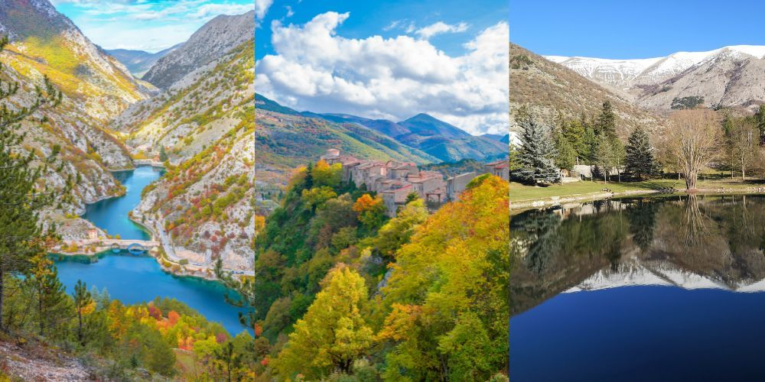
Villalago is a small mountain village, with a few hundred inhabitants, in the province of L'Aquila, located in the incredible beauty of the Abruzzo National Park at over 900 metres above sea level, near three lakes of great tourist importance: the small lake Pio, suitable for bathing , just outside the town centre; the marvelous lake Scanno, further south towards the village of the same name, with its unmistakable heart shape; and the fascinating lake of San Domenico, further north, a true oasis of peace and tranquility where you can take refuge, in contact with nature and its elements, sounds and scents.
https://maps.app.goo.gl/FHHmTvRpJhy6GESXA
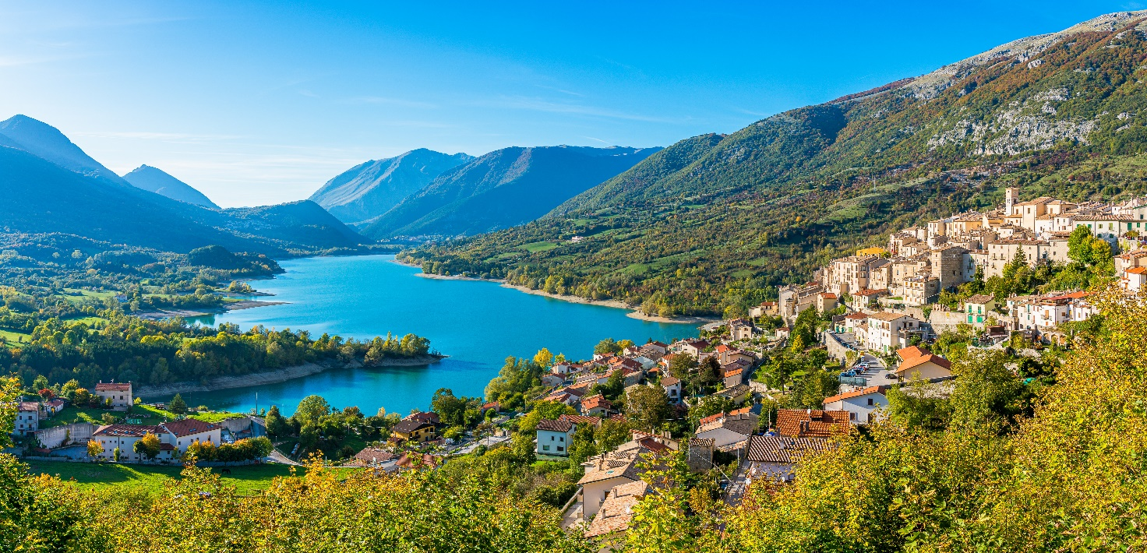
Lake Barrea offers the gaze a splendid postcard where the turquoise colour of the water dominates and on which the red of the setting sun is reflected at sunset.
The lake is artificial and it is located in the province of L'Aquila, at 972 metres above sea level. It is surrounded by a cycle and pedestrian path and in some places there are bathing beaches equipped with sunbeds and umbrellas dedicated to the summer period.
https://maps.app.goo.gl/2p3YgfBXCiQzzfKS7

At approxmiately 120 minutes

Roccaraso, Pescocostanzo, Pescasseroli.
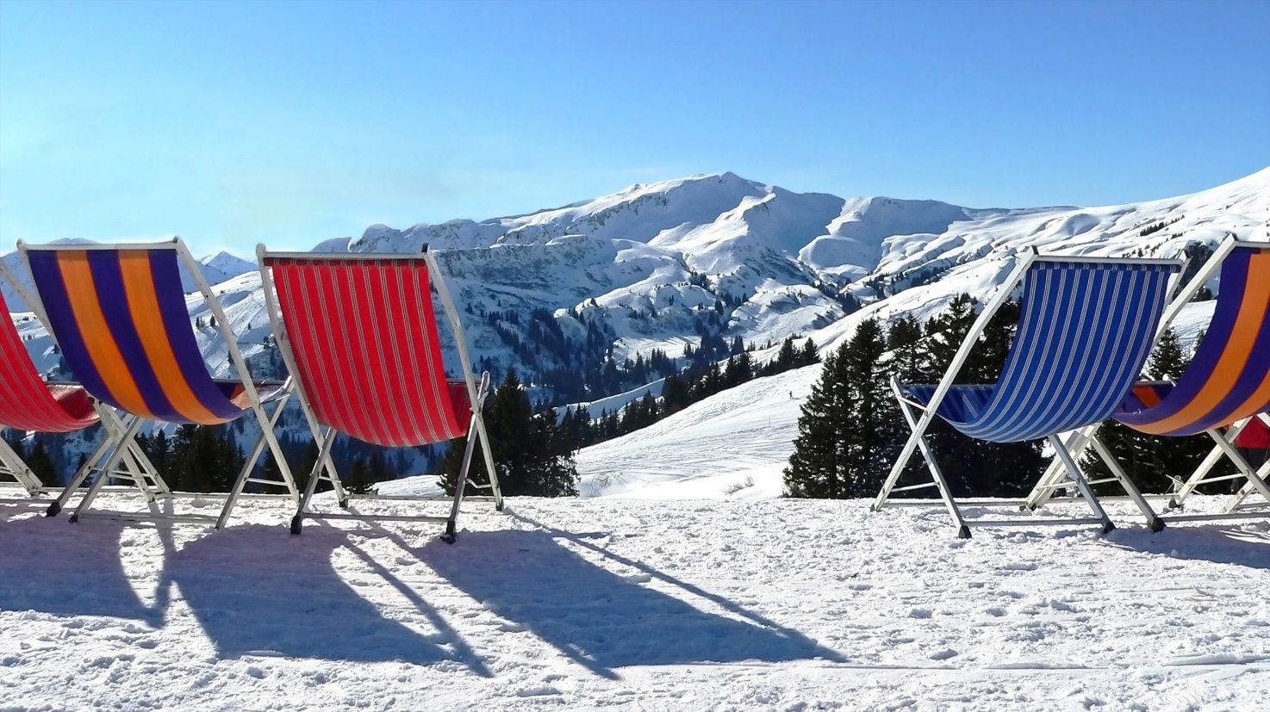
Roccaraso is one of the most famous ski resorts in Italy, loved for its well-groomed slopes and its welcoming atmosphere. Located in the Maiella mountains, Roccaraso offers over 110 km of slopes, making it the perfect destination for skiing and snowboarding enthusiasts.
https://maps.app.goo.gl/18Qtvq2K1GhGzraSA

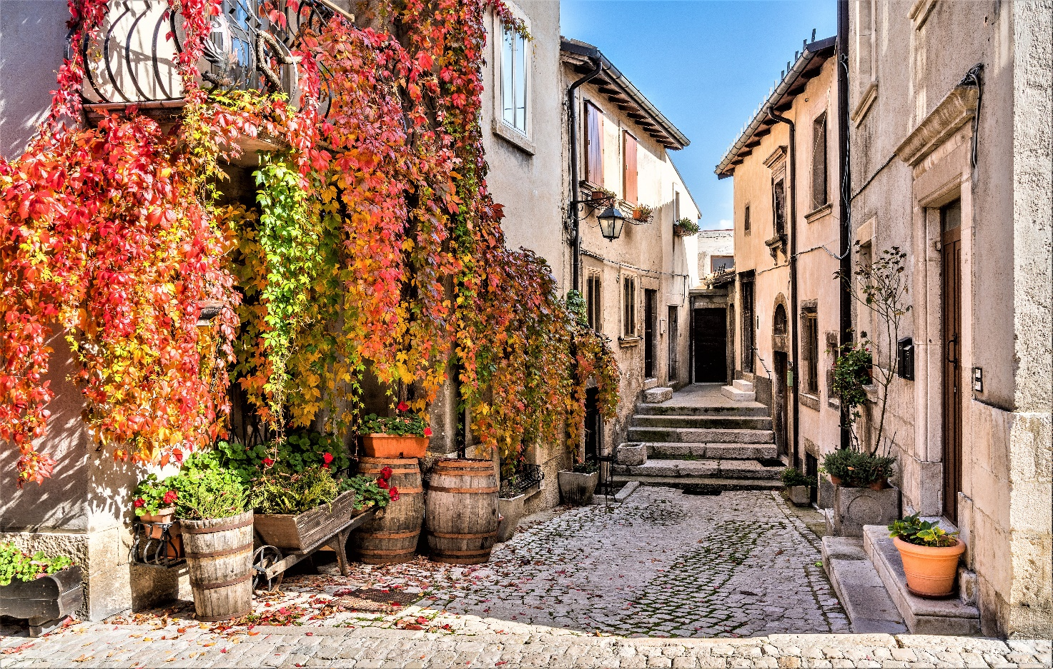
Pescocostanzo is an enchanting mountain town known for its traditional architecture, its artisan culture and its fascinating history. The town is a real jewel.
https://maps.app.goo.gl/9eGVzVGsMowxYXuA8

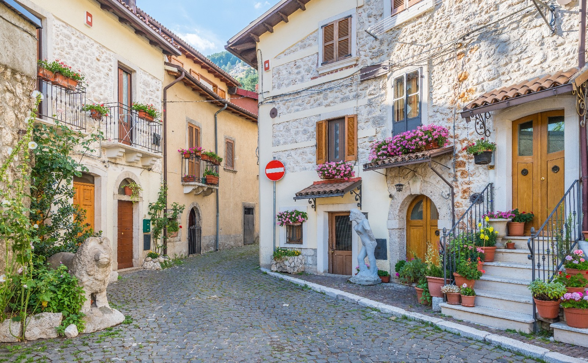
Pescasseroli is the heart of the Abruzzo, Lazio and Molise National Park, and offers a wide range of outdoor activities. Here, nature lovers can hike, bike, bird watch or venture out on horseback excursions.

https://maps.app.goo.gl/fHAedBLRTujvaEJN7

Villages…
A region that houses splendid parks, paradisiacal beaches and truly marvelous Apennine peaks, Abruzzo is also the land that preserves small villages with truly ancient history. Many of the villages of Abruzzo are real pearls, not to be missed during a trip to this splendid region, because they preserve a truly unique historical, architectural and cultural heritage, which must not only be conserved but also enhanced. Often those who decide to visit Abruzzo focus on its coastal cities or famous winter resorts, but in reality the inland areas are also very fascinating. Set among the Apennines or surrounded by the greenery of parks, the villages of Abruzzo are special places where time seems to have stopped and where you can still learn about the ancient traditions of the past.

Civitella del Tronto, Pietracamela, Santo Stefano di Sessanio, Roccascalegna, Castelli.
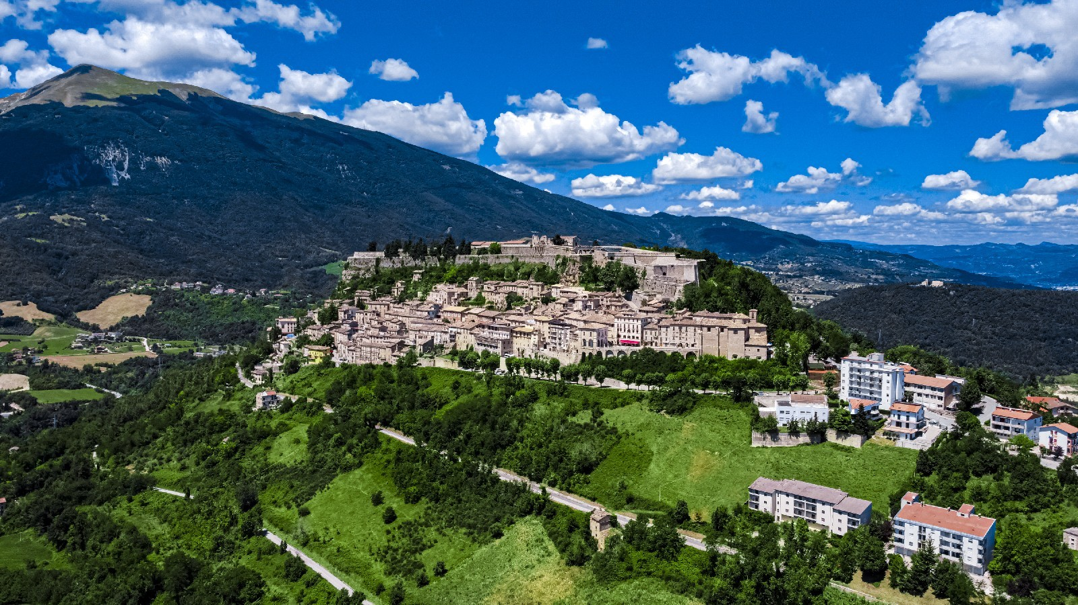

Located almost on the border with Le Marche, Civitella del Tronto is famous for its majestic fortress built on a hill at 600 metres above sea level, which is considered one of the largest and most important works of military engineering. Built in a strategic position, compared to the ancient border between the Viceroyalty of Naples and the Papal State, the complex extends over an area of 25,000 square metres and from up there, offers a beautiful panorama that ranges from the Gran Sasso massif to the Laga Mountains, from the Maiella to the Adriatic Sea. The town of Civitella developed under the fortress and is characterized by the presence of stone buildings, stairways and narrow streets where sometimes only one person can pass at a time. In fact, the "Ruetta", which is said to be the narrowest street in Italy, is located right in Civitella. The city was built in this way for defensive purposes, to make the enemy's advance difficult. Outside the historic centre, it is possible to take a beautiful excursion to the Gole di Salinello, a magnificent canyon surrounded by greenery.
https://maps.app.goo.gl/g8nDsYb5itWpKQQ96
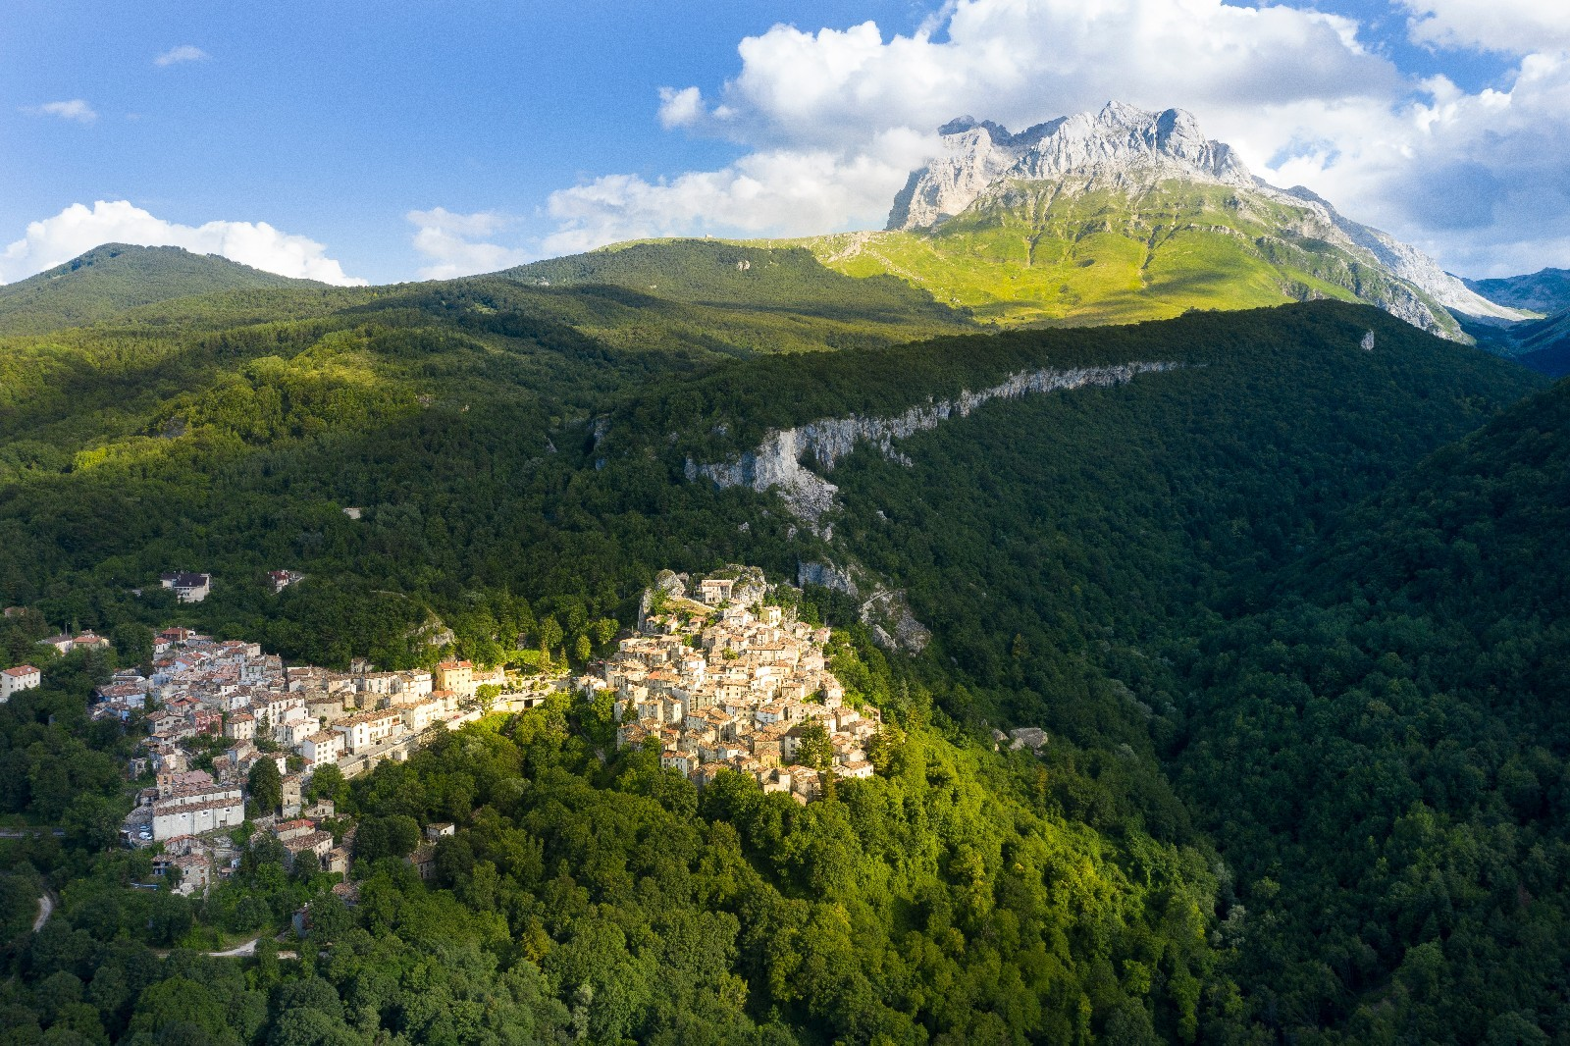

The small village of Pietracamela is located within the Gran Sasso and Monti della Laga National Park and rises on the slopes of Corno Piccolo, one of the highest peaks within the Gran Sasso massif. This village, with stone buildings, dating back to the 15th and 16th centuries, is a place to discover for its simplicity and tranquility.
https://maps.app.goo.gl/YL4HtGKg94fWuRfG6
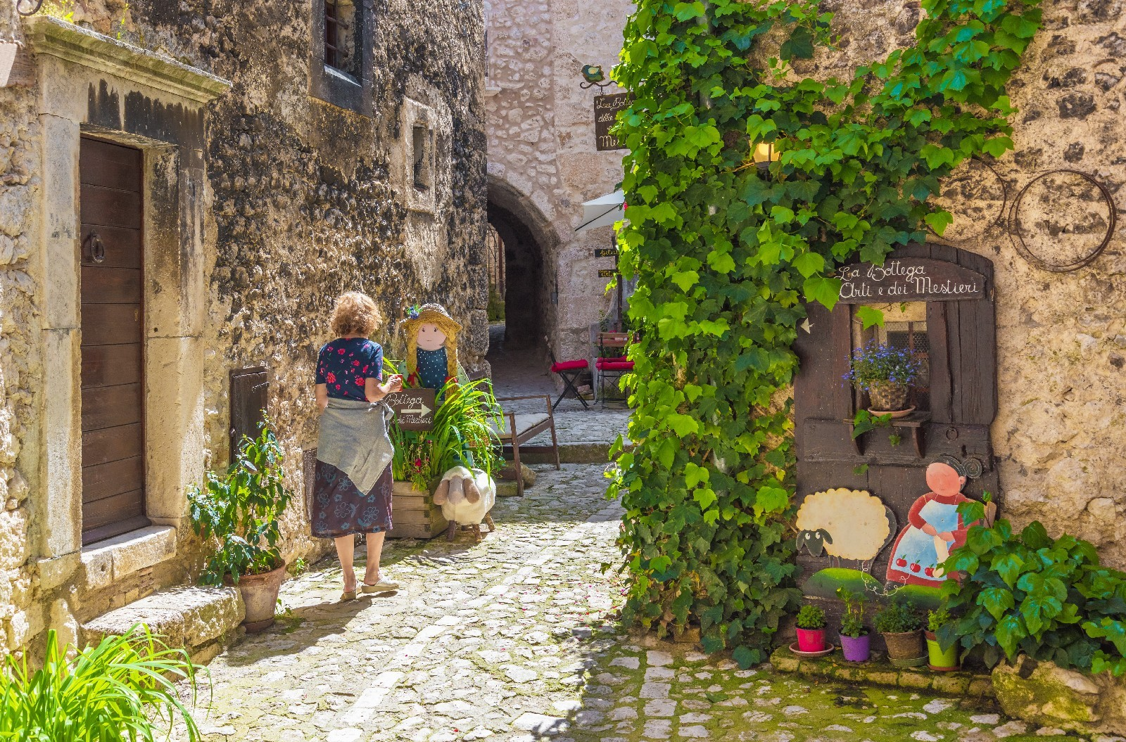
A charming medieval village, located at 1250 metres above sea level, within the Gran Sasso and Monti della Laga National Park, Santo Stefano di Sessanio is undoubtedly a destination not to be missed during a trip to Abruzzo. The current urban layout of the city dates back to the Middle Ages and is part of that very widespread process in Abruzzo which saw the birth of small fortified towns created in places that were not easy to reach, to defend themselves from enemy invasions. Walking through Santo Stefano di Sessanio, among the houses and streets built in white limestone, it feels like taking a beautiful journey back in time. This location has become internationally famous thanks to the initiative of Daniele Kihlgren, a Swedish entrepreneur who purchased many of the abandoned houses in the historic centre and converted them into hotels while preserving, however, the aesthetics of the village. This project took the name of "widespread hotel" and made Santo Stefano a very sought-after destination.
https://maps.app.goo.gl/k4V7PdaC3F5V44AQA

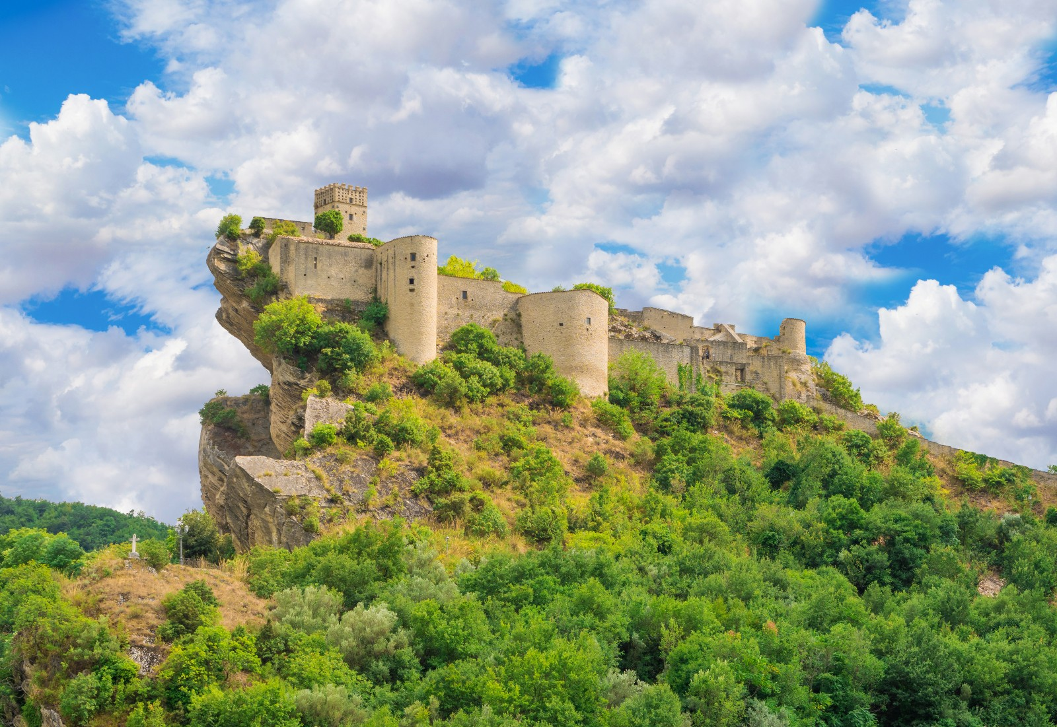
Awarded the Orange Flag title by the Italian Touring Club, Roccascalegna is one of the most spectacular villages in the region. The symbol of the town is undoubtedly the medieval castle of Roccascalegna, one of the most powerful fortresses in Abruzzo which dominates the village from the top of a rocky spur.
https://maps.app.goo.gl/9DiUdmoMjgngDXtm6

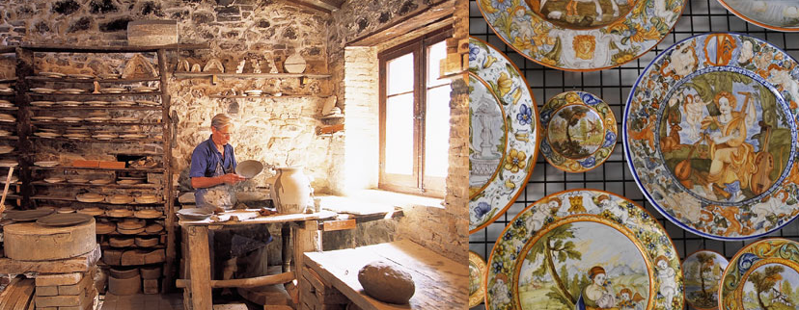
Castelli: the village in Abruzzo noted for its ancient ceramics.
Castelli keeps its cultural and artistic tradition alive in ceramics. Along the main street of the town, characterized by a staircase, it is possible to admire the various production laboratories. It is possible to see up close how this precious material is produced, through the numerous shops and laboratories of the ancient masters.
https://maps.app.goo.gl/d35GG4gYyACTGpnq5

Towns and villages nearby....

Atri, Città Sant’Angelo, Penne, Loreto Aprutino.
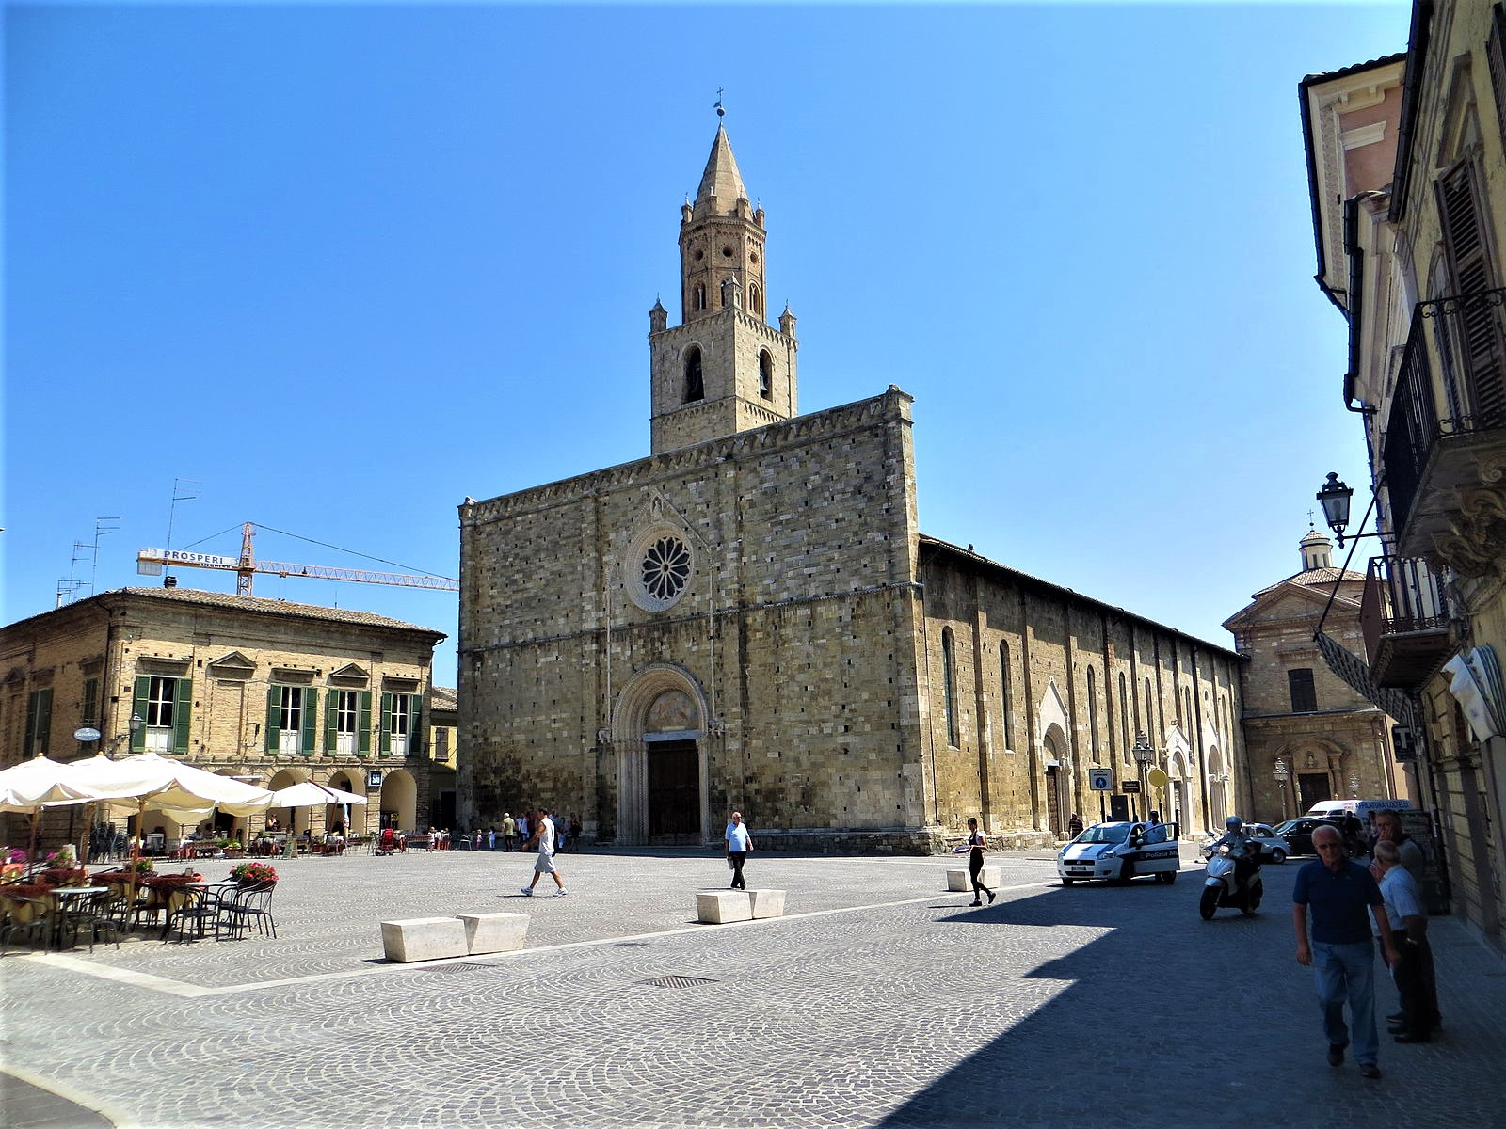

Atri is one of the most beautiful and characteristic towns in Abruzzo - rich in history and culture, and not far from the sea. Of pre-Roman origins, in this village the past and the present blend together without creating any type of contrast. Atri has always been known for the production of liquorice, a real tradition that seems to date back to Roman times. Tasting the liquorice of Atri is one of the things you absolutely must do, by purchasing it in one of the historic shops in the centre. Atri is also famous for its characteristic "calanchi" and its reserve.
The Calanchi d'Atri Nature Reserve is a protected natural area that extends for approximately 380 hectares in the territory of the municipality of Atri and is managed by the WWF. The area is home to a great variety of both animal and plant species.
https://maps.app.goo.gl/xqbnY7rTaPfqgiDA6
https://www.calanchidiatri.it
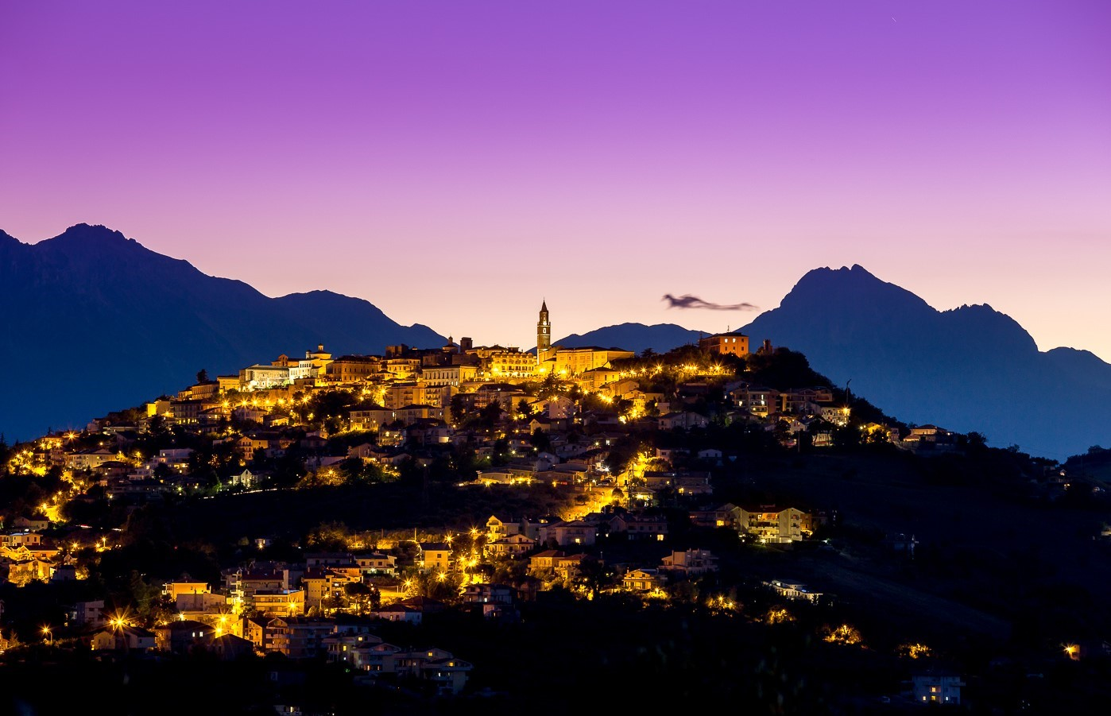

In Abruzzo, and more precisely on a hill 317 metres above sea level which stands out in the province of Pescara, stands a village which is a true treasure chest and which strikes visitors with its liveliness, traditions, typical products and for the landscape that seems to have come out of a postcard. The place in question is called Città Sant'Angelo.
Forbes has ranked Città Sant'Angelo among the 5 best places in the world to live. But it is also one of the most beautiful villages in Italy, Citta ‘Slow’, City of Wine and of Oil.

https://maps.app.goo.gl/gJ1tjS5ZkNZCEPTQ7
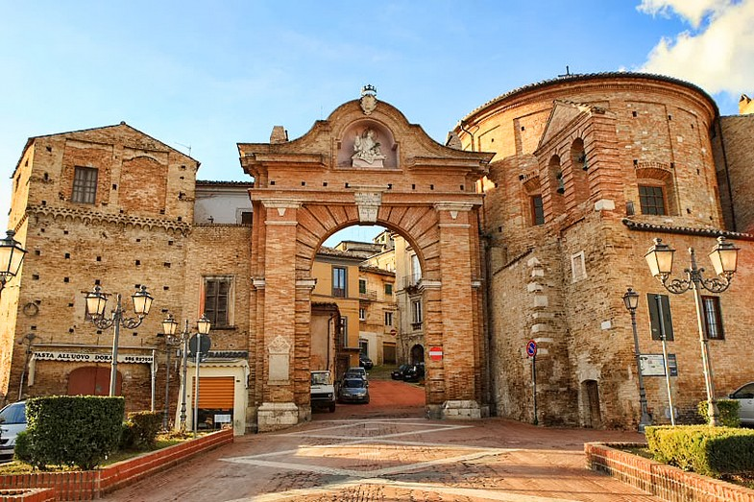
Penne, the city of bricks, included among the most beautiful villages in Italy, is a perfect mix of art, history and nature. A historic centre, full of monuments, palaces and churches, is capable of surprising anyone who decides to visit it. Located at the same distance between the sea and the mountains, in an excellent hilly position, a natural gateway to the Gran Sasso and Monti della Laga National Park, via the “Lago di Penne” Nature Reserve.
https://maps.app.goo.gl/1vLGFe1F46MnQ8yF6
www.riservalagodipenne.com
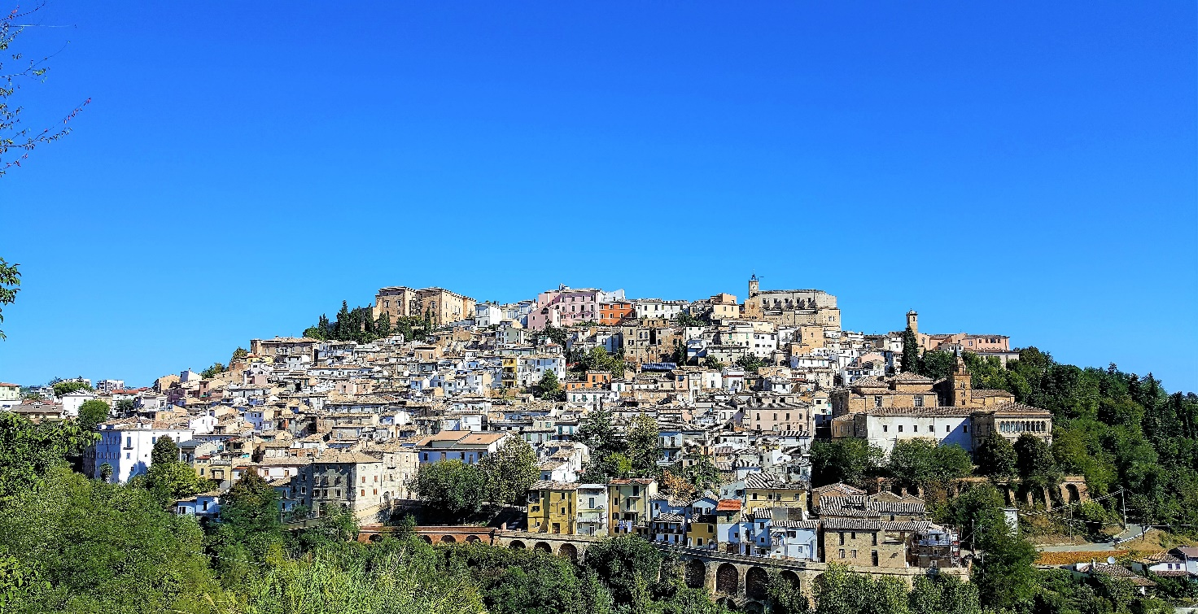

In the province of Pescara, Loreto Aprutino is an Abruzzo jewel waiting to be discovered. Awarded with the title of City of Oil, the town boasts an ancient history and a great cultural depth, so it is a recommended place to visit. Nestled between the Pescara coast and the Gran Sasso, it dominates the Tavo river and the immense expanses of olive groves from the top of a hill. Walking through the historic centre, among the 300 most beautiful villages in Italy, you immediately notice the characteristic medieval appearance among the entrance doors, alleys, picturesque streets, houses and stately buildings that huddle around the Castle, an imposing city symbol with a great impact visual.

https://maps.app.goo.gl/ig32j5cAsuCKRwMv6

Arsita, Bisenti, Castiglione Messer Raimondo, Castilenti, Montefino.

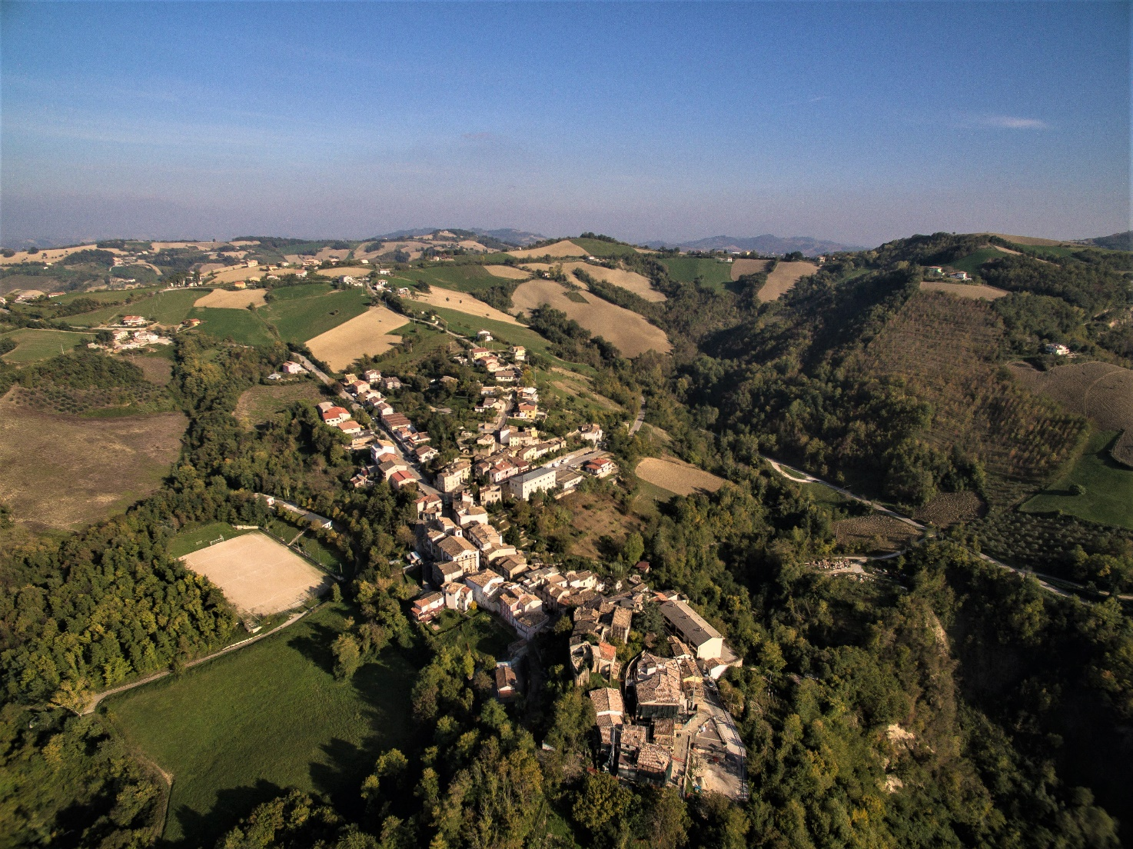
ARSITA
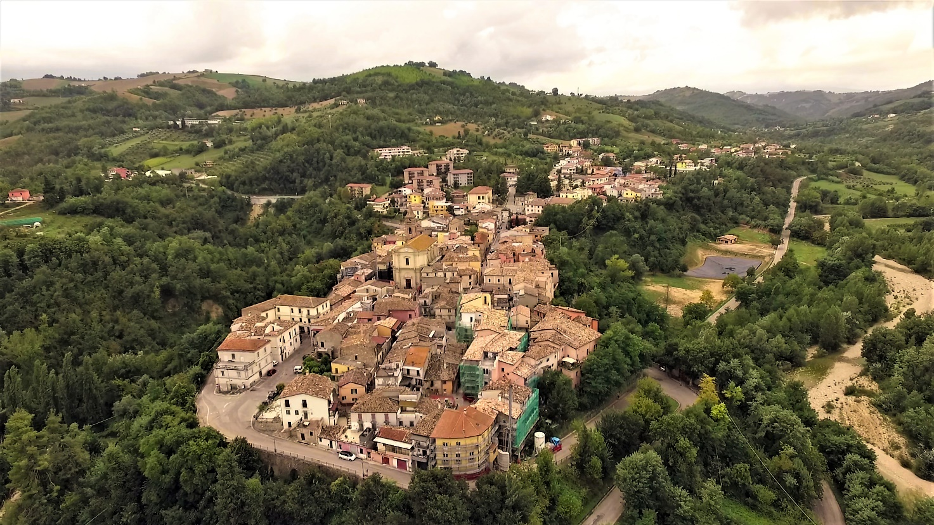
BISENTI
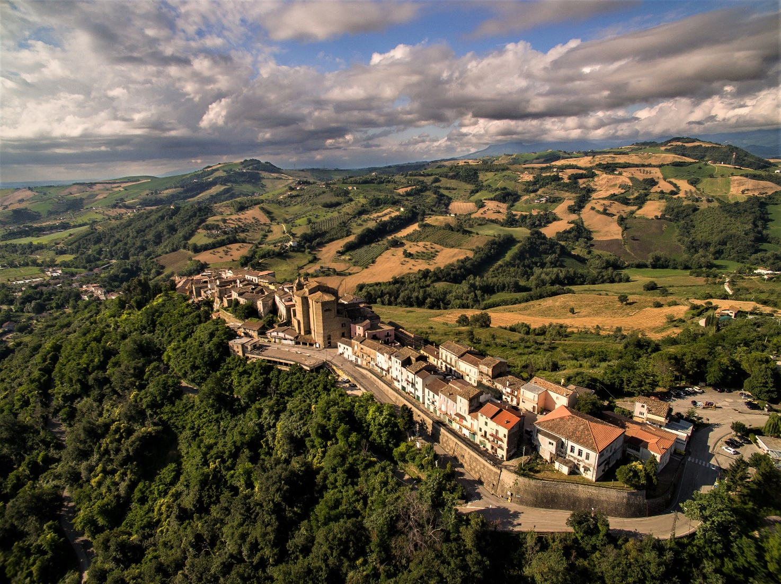
CASTIGLIONE MESSER RAIMONDO

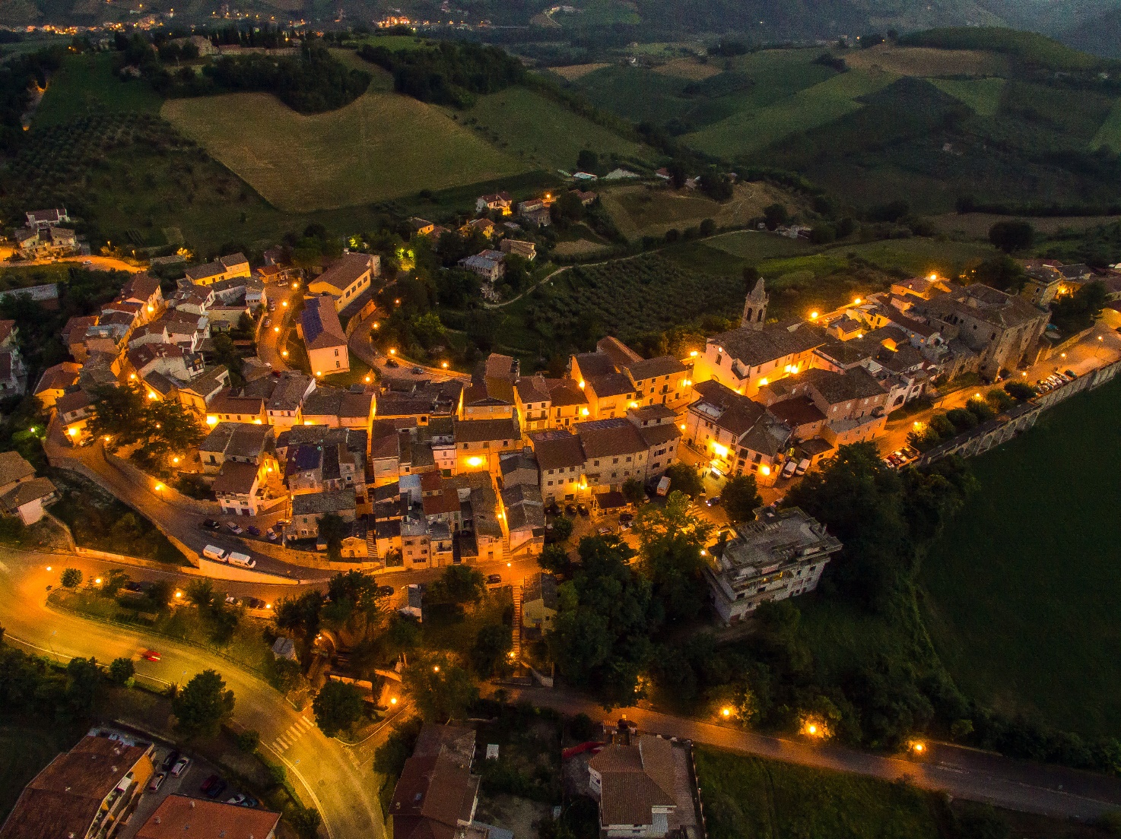
CASTILENTI
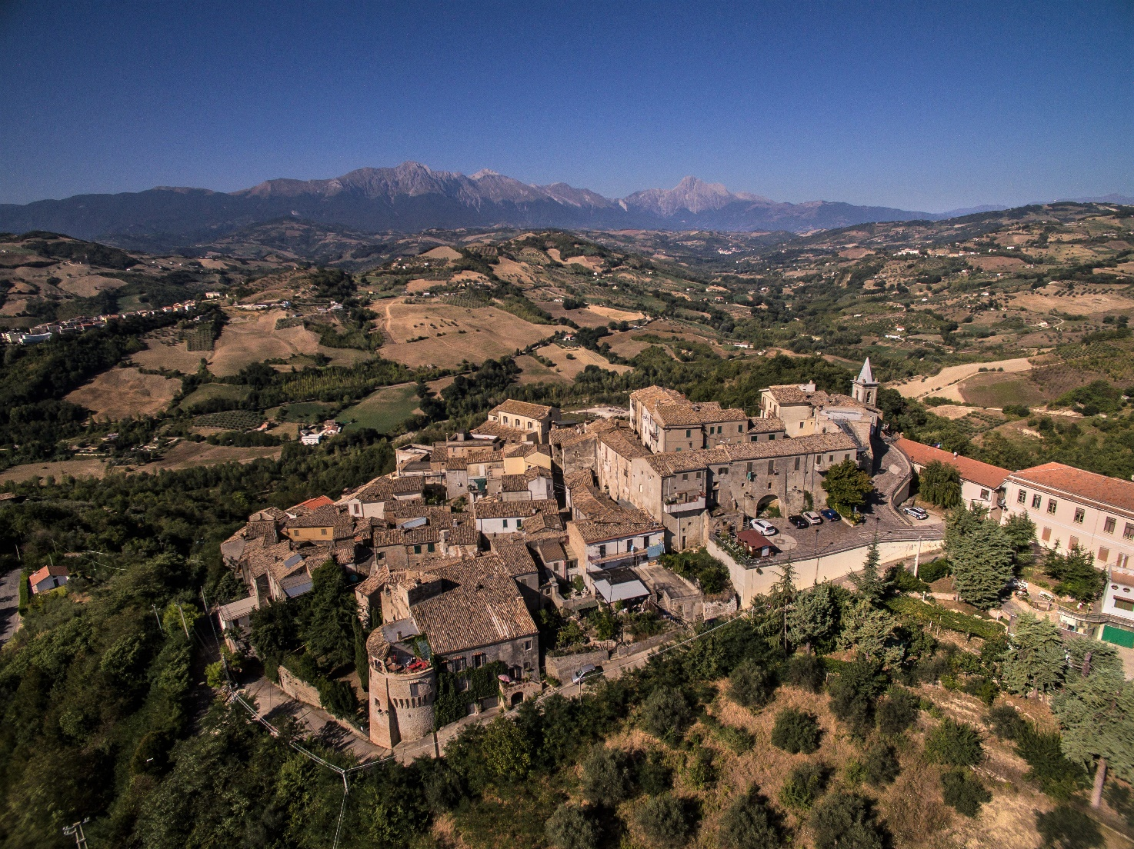
MONTEFINO

